# Naive Bayes

**Instructions:**

Please share your answers filled in-line in the word document. Submit code separately wherever applicable.

Please ensure you update all the details:

**Name:RAKESH SETHU NP Batch ID: 11052022_7.30PM**

**Topic: Naïve Bayes**

**Hints:**

1. **Business Problem**
   1. **What is the business objective?**
   2. **Are there any constraints?**
2. **Work on each feature of the dataset to create a data dictionary as displayed in the below image:**

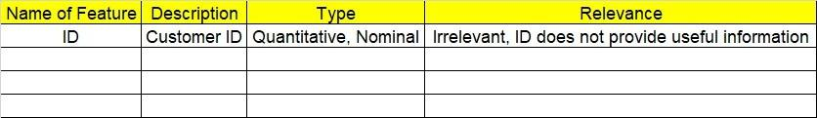

**2.1 Make a table as shown above and provide information about the features such as its data type and its relevance to the model building. And if not relevant, provide reasons and a description of the feature.**

1. **Data Pre-processing**

**3.1 Data Cleaning, Feature Engineering, etc.**

1. **Exploratory Data Analysis (EDA):**
   1. **Summary.**
   2. **Univariate analysis.**
   3. **Bivariate analysis.**
2. **Model Building**
   1. **Build the model on the scaled data (try multiple options).**
   2. **Build a Naïve Bayes model.**

**5.3 Validate the model with test data and obtain a confusion matrix, get precision, recall, and accuracy from it.**

**5.4 Tune the model and improve the accuracy**

**6. Write about the benefits/impact of the solution - in what way does the business (client) benefit from the solution provided?**

**Problem Statement:**

1.) Prepare a classification model using the Naive Bayes algorithm for the salary dataset. Train and test datasets are given separately. Use both for model building. 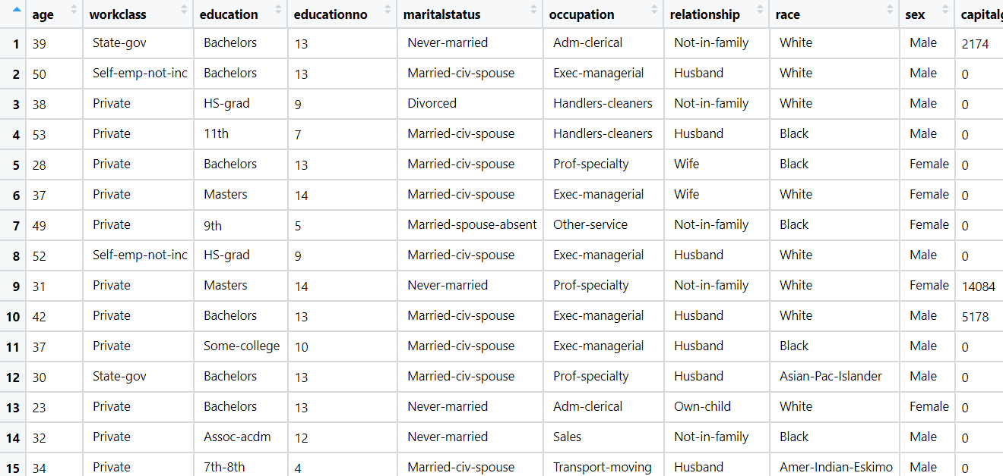

**Problem Statement: -**

This dataset contains information of users in a social network. This social network has several business clients which can post ads on it. One of the clients has a car company which has just launched a luxury SUV for a ridiculous price. Build a Bernoulli Naïve Bayes model using this dataset and classify which of the users of the social network are going to purchase this luxury SUV. 1 implies that there was a purchase and 0 implies there wasn’t a purchase.

**Problem Statement: -**

In this case study, you have been given Twitter data collected from an anonymous twitter handle. With the help of a Naïve Bayes model, predict if a given tweet about a real disaster is real or fake.

1 = real tweet and 0 = fake tweet

